**Jakob Roberts - V00484900 - SENG 371 - Lab 1**

1)

1. 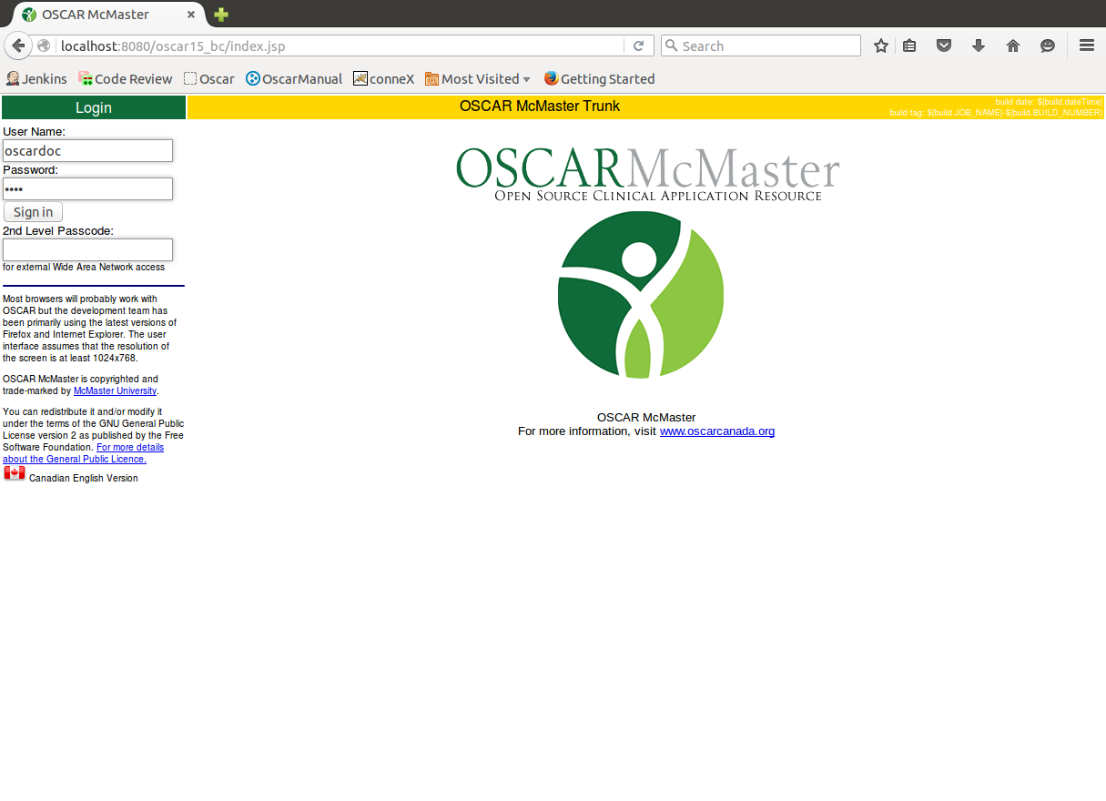
2. 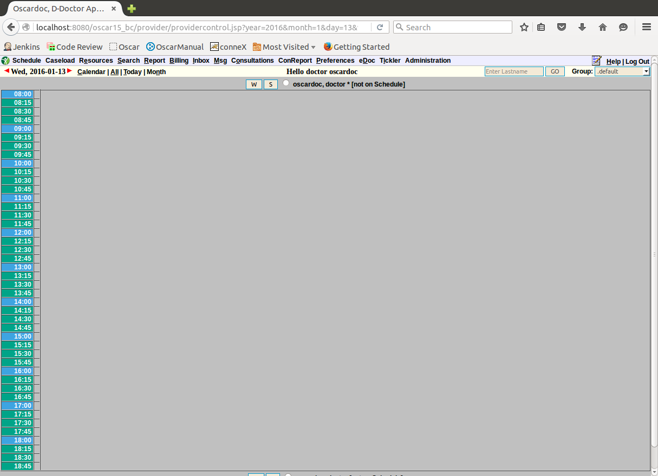
3. 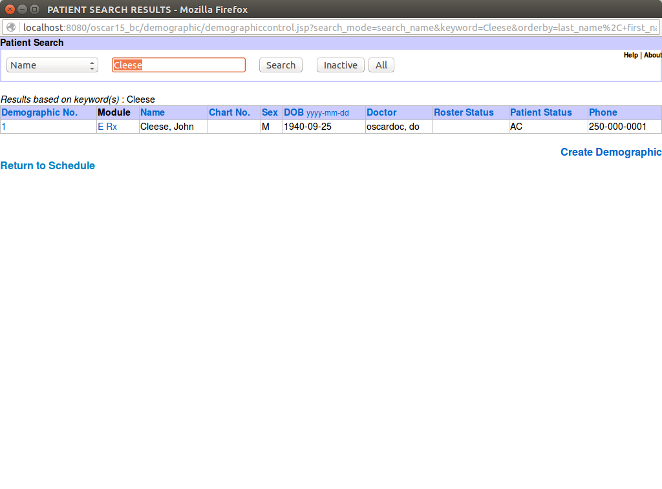
4. 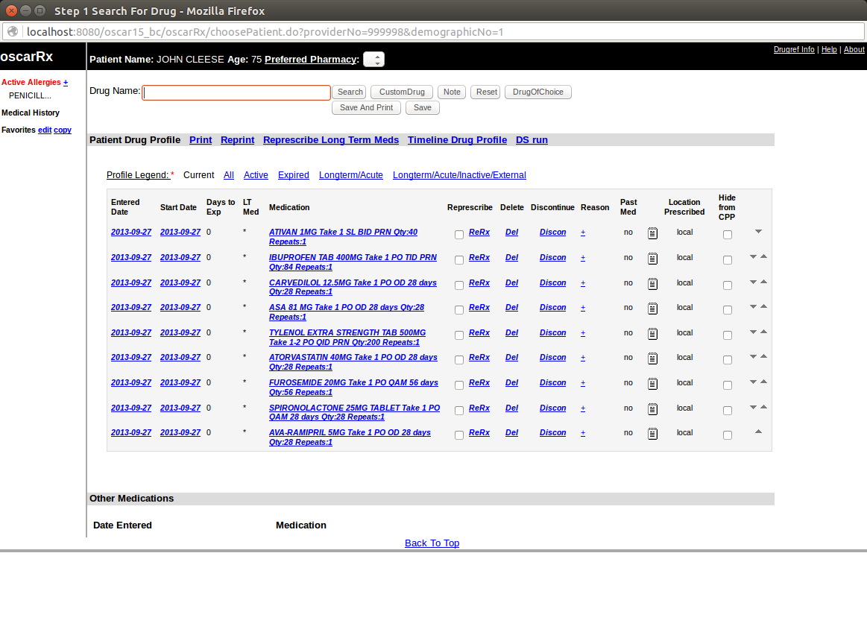
5. 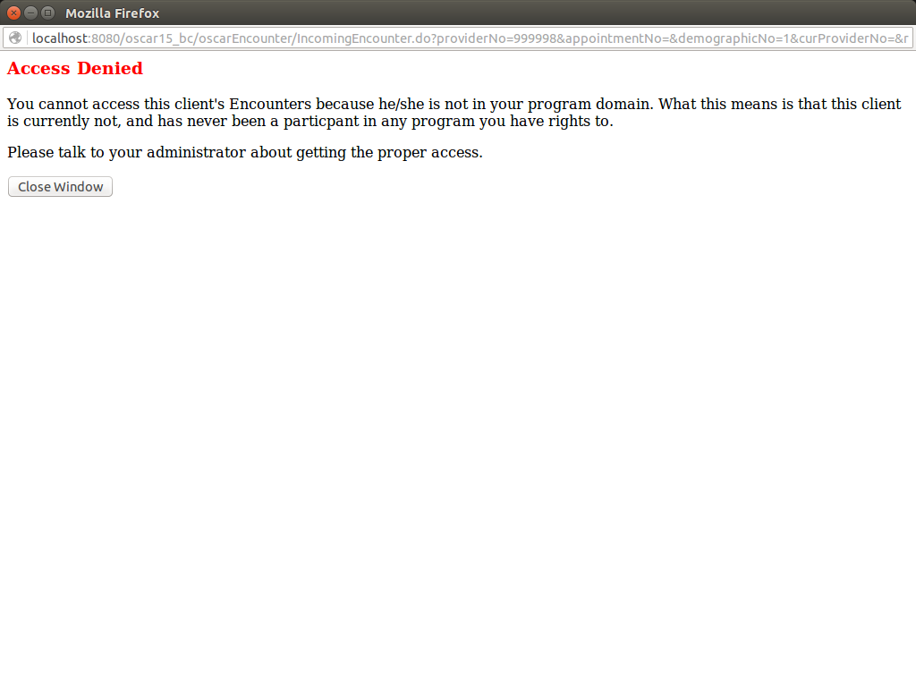
6. Made new patient chart
7. 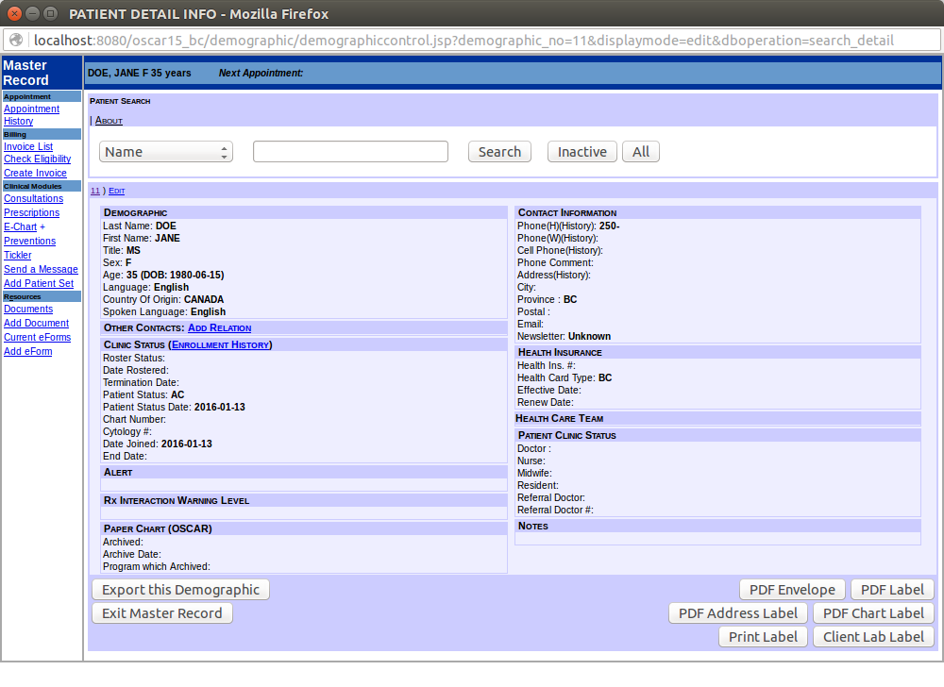
8. Prescribed new meds
9. 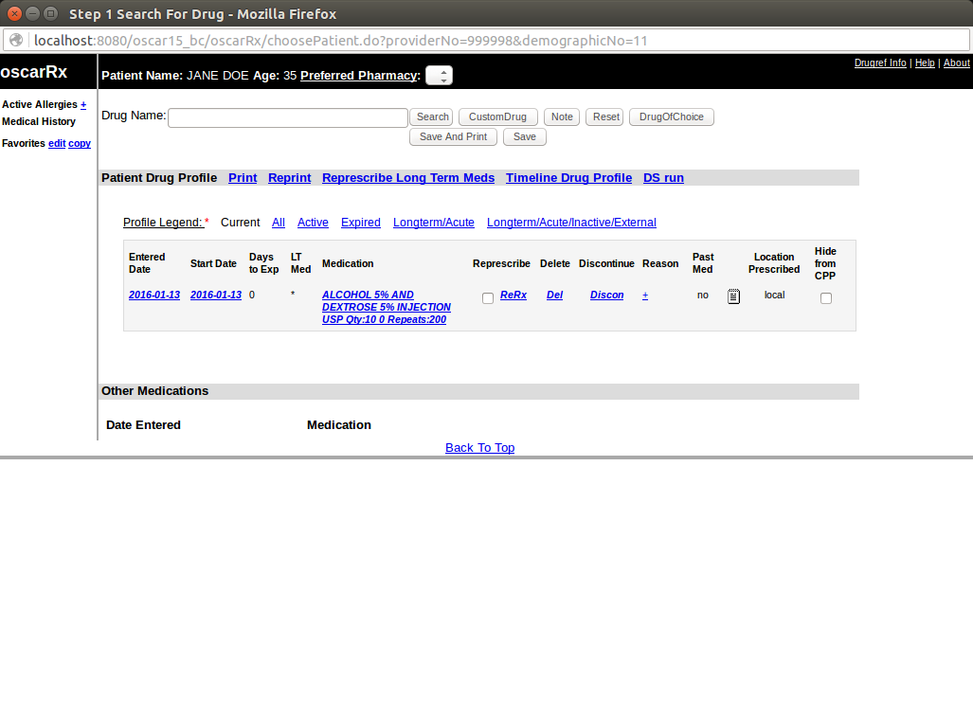

2)

|  |  |
| --- | --- |
| **History** | **Setup Guide** |
| Update VM Envr | VM Environment |
| Install Java 7 | Install Java |
| Install mysql tomcat | Install MySQL |
| Install Java 7 again, then git, then maven | Install Git, Maven, Tomcat |
| Config ENV vars, and installed lots of stuff | Configure Environment Variables |
| clone OSCAR | Generate SSH key |
| ssh keygen | Link github and SSH key |
| clone OSCAR again? + lots of configs | Clone OSCAR |
| rsync stuff, mysql config, “oscarbuild12bc” | Compile & Deploy OSCAR to Tomcat |
| attempts to deploy, had to make changes | Deploy OSCAR docs to Tomcat |
| more SQL configs | OSCAR Configuration |
| use SQL and config drugref | Configure Tomcat Memory Usage |
| install eclipse | Configure MySQL |
|  | Import and update Drugref |
|  | Config OSCAR Deployment |
|  | Install Eclipse |
|  | Configure Eclipse |
|  | Remote Tomcat Debugging |

1. The “oscarstart” script is very basic. It starts off by checking if mysql has started, if not, start it. Then export environment variables for Tomcat7 and java operators. Then it checks if tomcat is running, if it hasn’t, then start, else restart. That’s it, very simple script checking on mysql and tomcat only.

3)

1. OSCAR initially was supposed to use Java version 6 based on the start scripts, but in this build it used Java version 7 and it “magically” worked without any apparent problems.
2. It uses MySQL which is a form of relational database. This can be seen with the startup script “oscarstart”.
3. <http://oscarcanada.org/> seems to provide some resources about the product.